C O M E N I U S NO: 2012-1-CY1-COM06-02376 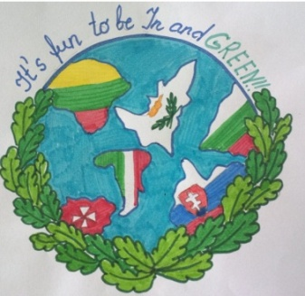
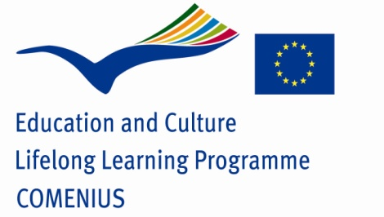
TASKS FOR STUDENTS FROM JANUARY TO MARCH 2014
- 1.Glossary/ Glosár, alebo slovná zásoba spojená s témami:
Jobs of the future & Houses of the future & Cars and transport of the future & Clothing in the future&Global changing- nature in the future Deadline: 15 February 2014
!!!/Do not worry, your teachers will give you „1“ for your projects/
- 2.Create ecology masks for our carnival customs – the best one we
will take to Project meeting in Malta. Deadline:28 February 2014
- 3. : Eco – advertisement- a competition - Houses of the future
Deadline: 31 January 2014
e.g. Eco house-future houseI love my EARTH!
BE CREATIVE!!! DO NOT COPY FROM THE INTERNET !!!
GIVE YOUR PROJECTS TO YOUR ENGLISH TEACHERS

